BOTOX EVENTS & Parties

If you’re looking for a fun and unique way to gather with friends, celebrate a holiday/event or wish to promote your business, all the while, saving some money!
Consider hosting a BOTOX event/party!
Forget those antiquated Tupperware or Avon parties…We are happy to reserve the building for you at Genesis Med Spa for your event!
Or
If you’re an area business and want to promote it in a special way, while driving throughput at your facility, we can travel to you!
See below for more details…
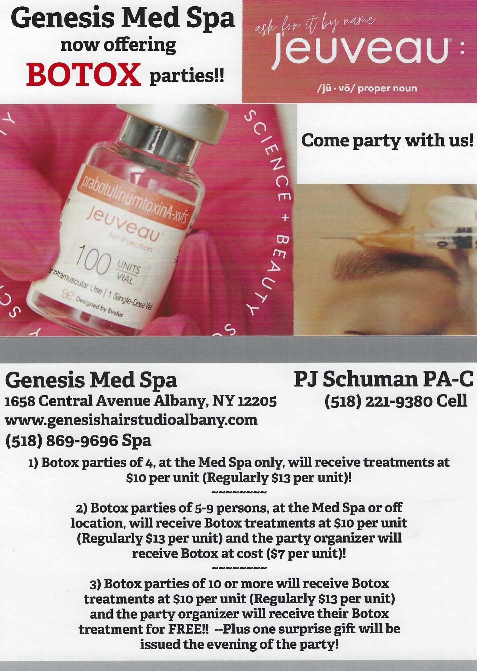
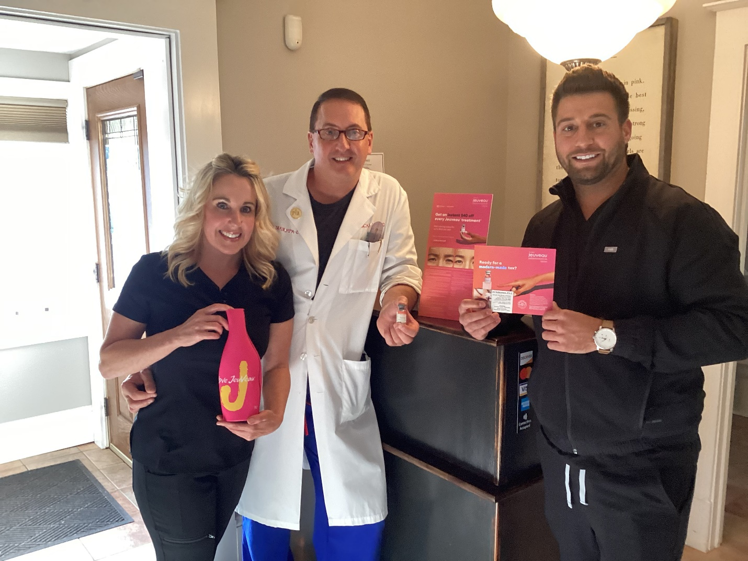

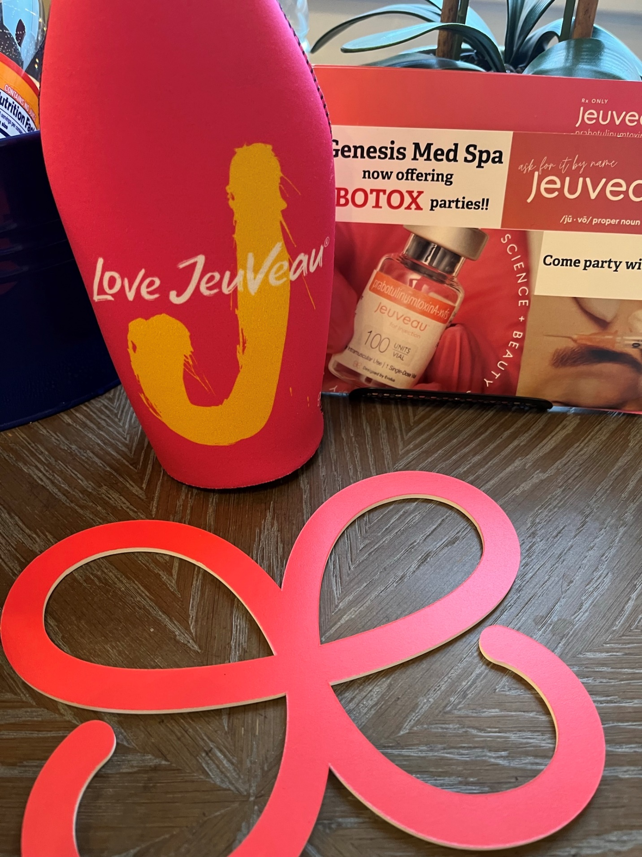

PLAN FUN HOLIDAY EVENTS/PARTIES at GENESIS MED SPA!!!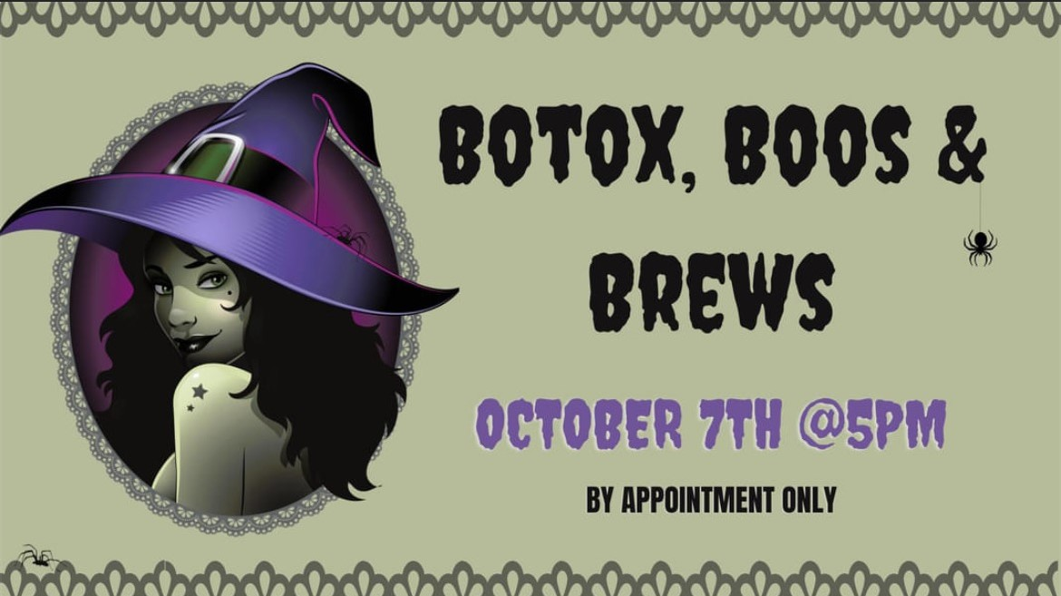

PROMOTE YOUR BUSINESS by HOSTING an ONSITE BOTOX EVENT!
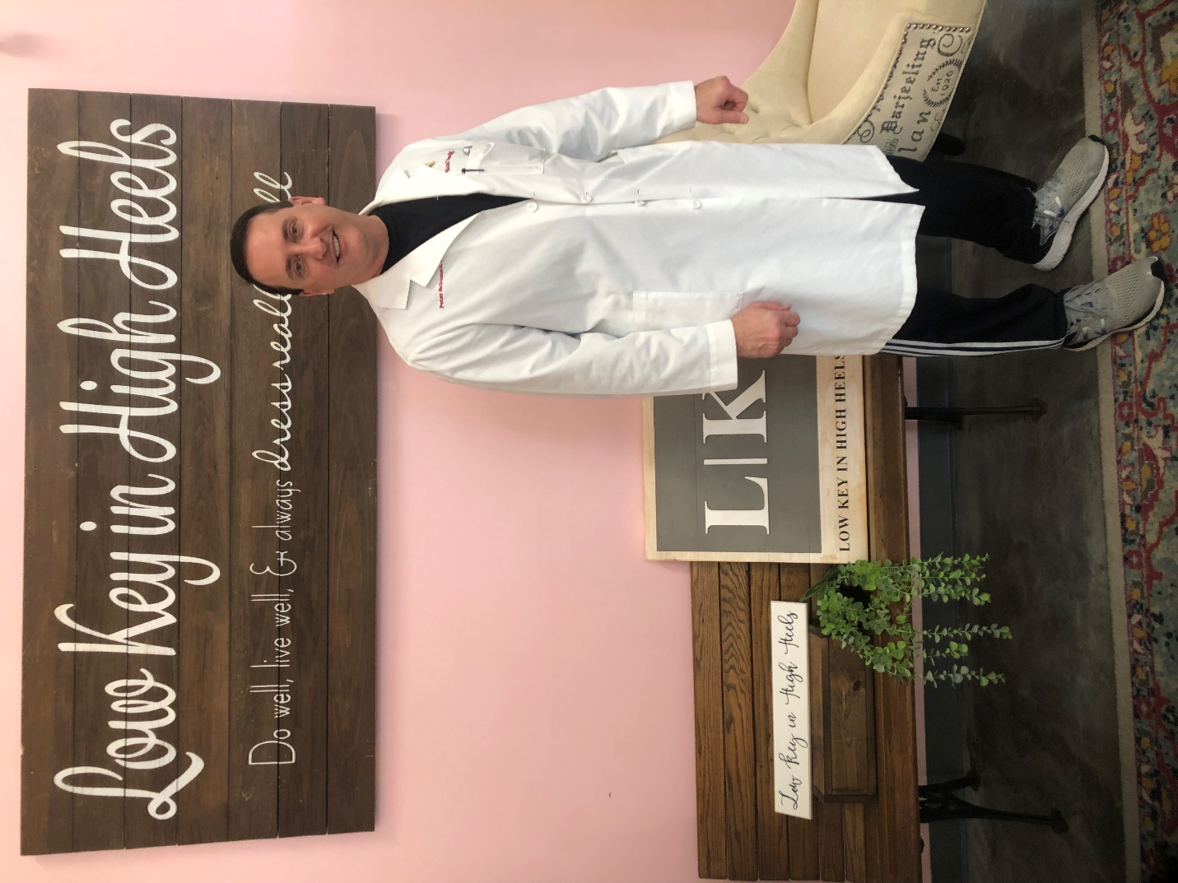

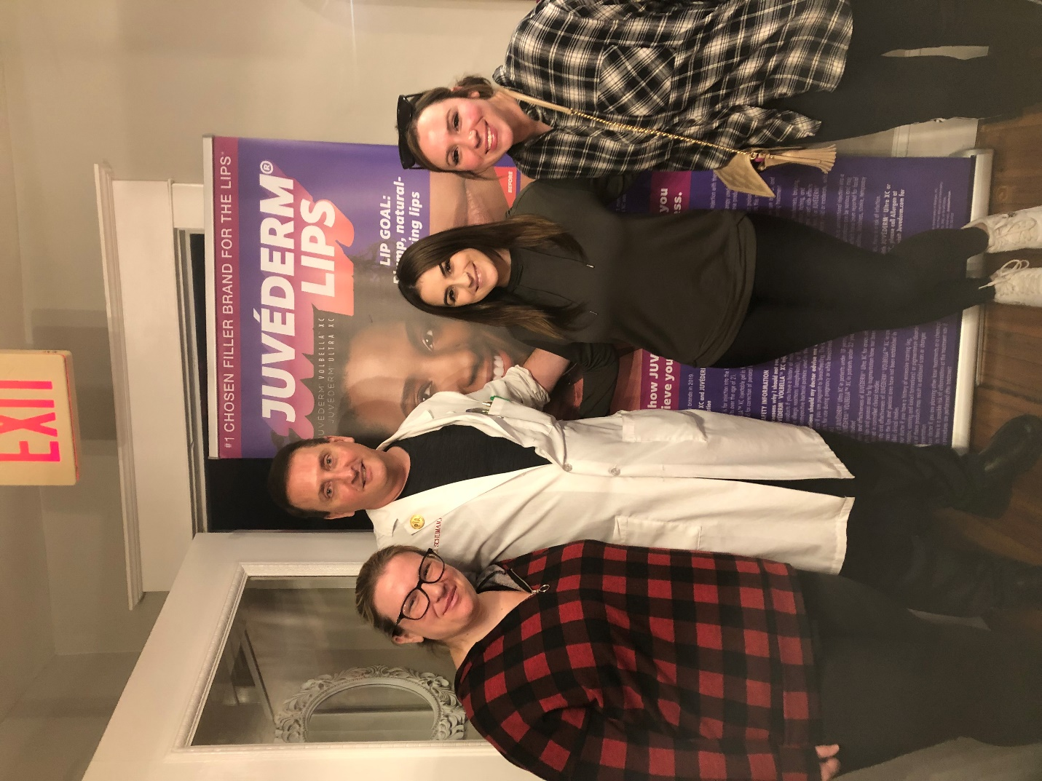

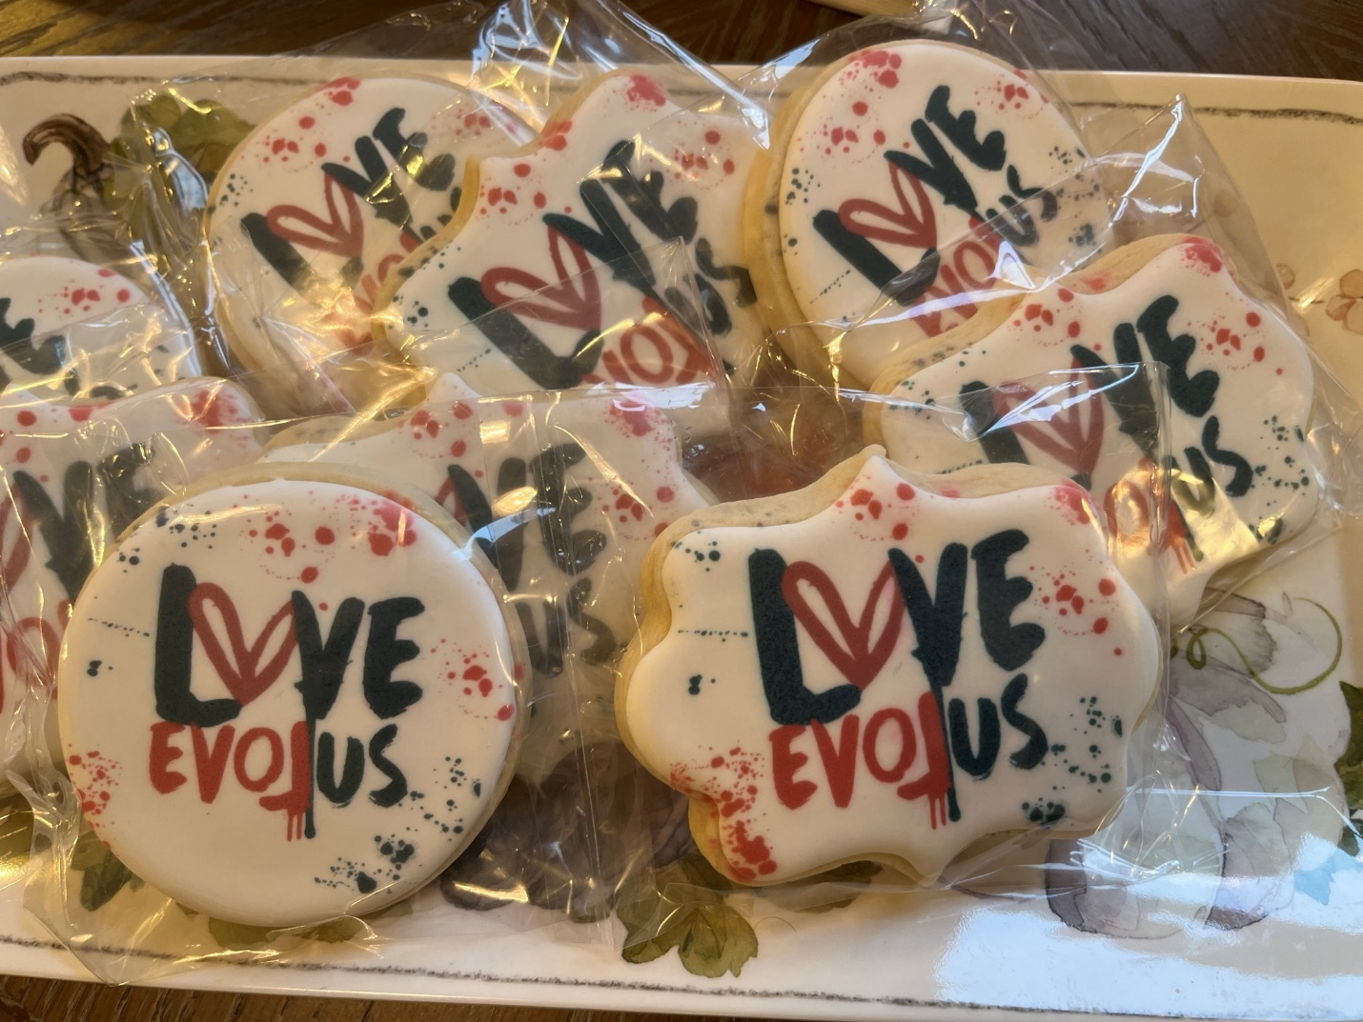

Call Genesis Med Spa today for further details!
518-869-9696 / 518-221-9380
radpapete@gmail.com

